**Google Assistant Based Home Automation Using Arduino**

**Steps to be Followed:**

1. **Repositories to Install:**

**Python 3.0 or above (Download it from** <https://www.python.org/downloads/>

**and install it** )

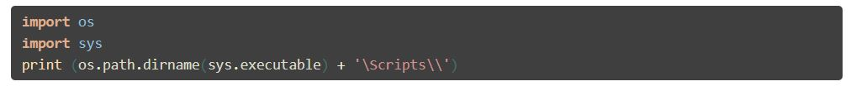**for Setting pip in windows: Type the following in idle python3**

**you will get the output as C:\Python37\Scripts\**

**then Follow the following procedure:**

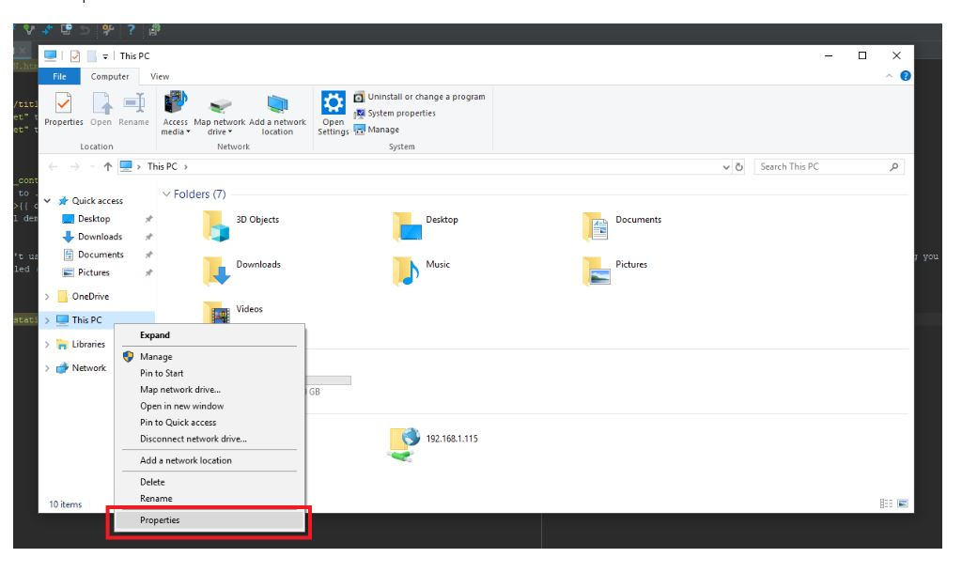

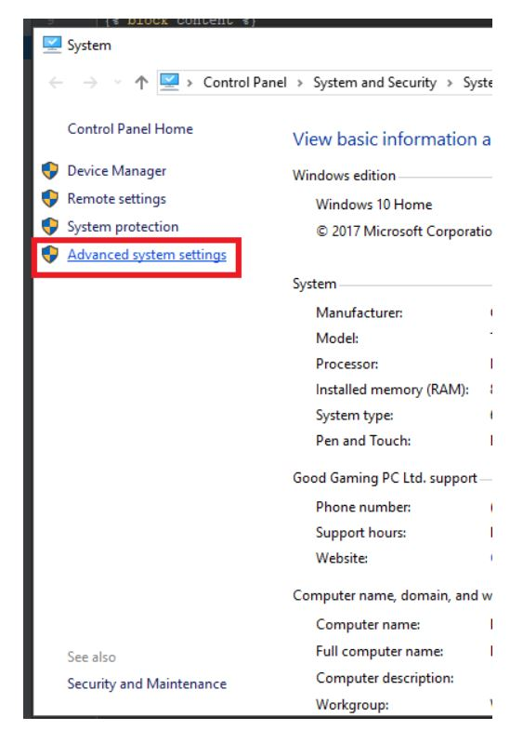

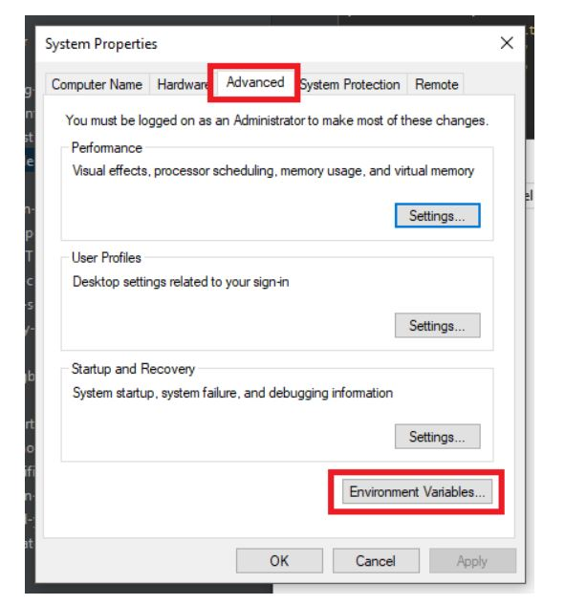

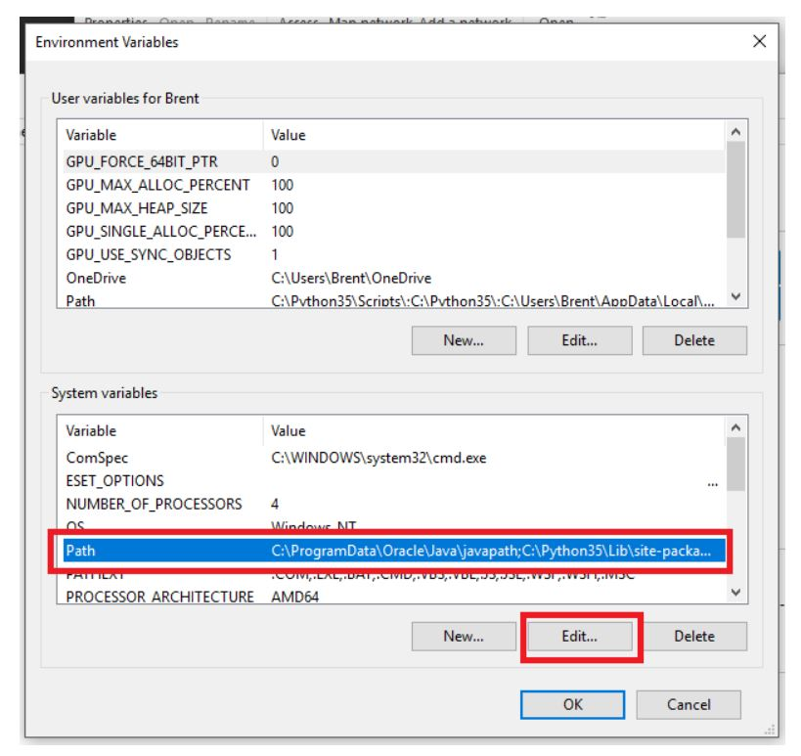

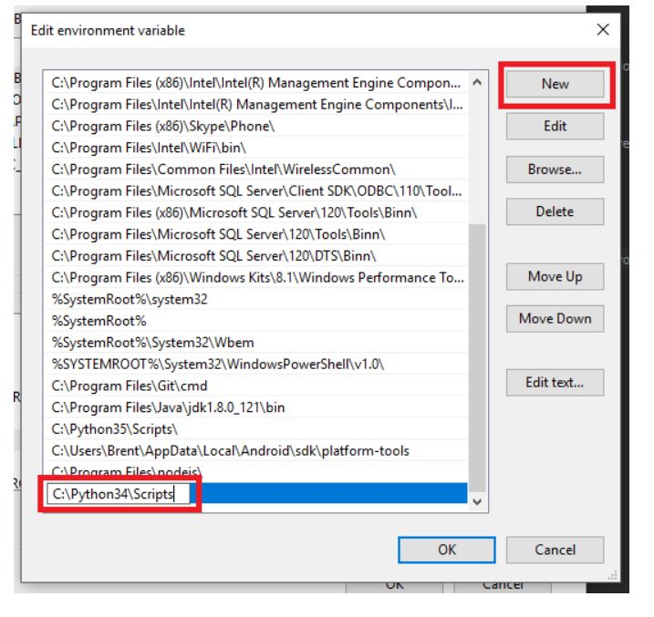

Click on new and paste the output as displayed before. This is applicable for python run time environment setup too.

**Open cmd and type :**

**pip3 install adafruit-io**

**pip install pyserial**

1. **Setting up Adafruit IO and IFTTT applet**

**Signing Up and creating Feed in Adafruit IO (visit**

[https://io.adafruit.com/](https://io.adafruit.com/ ) **)**

**AFTER YOU SIGNIN**

save Your AIO KEY and USERNAME in notepad: click on **View AIO KEY**

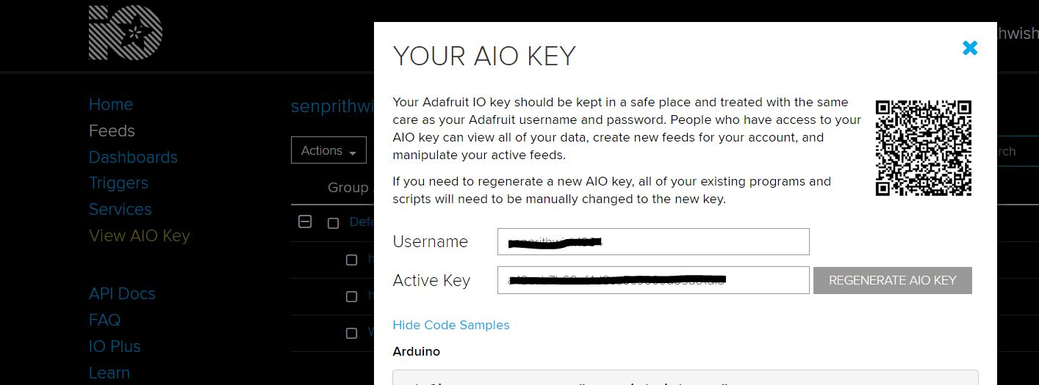

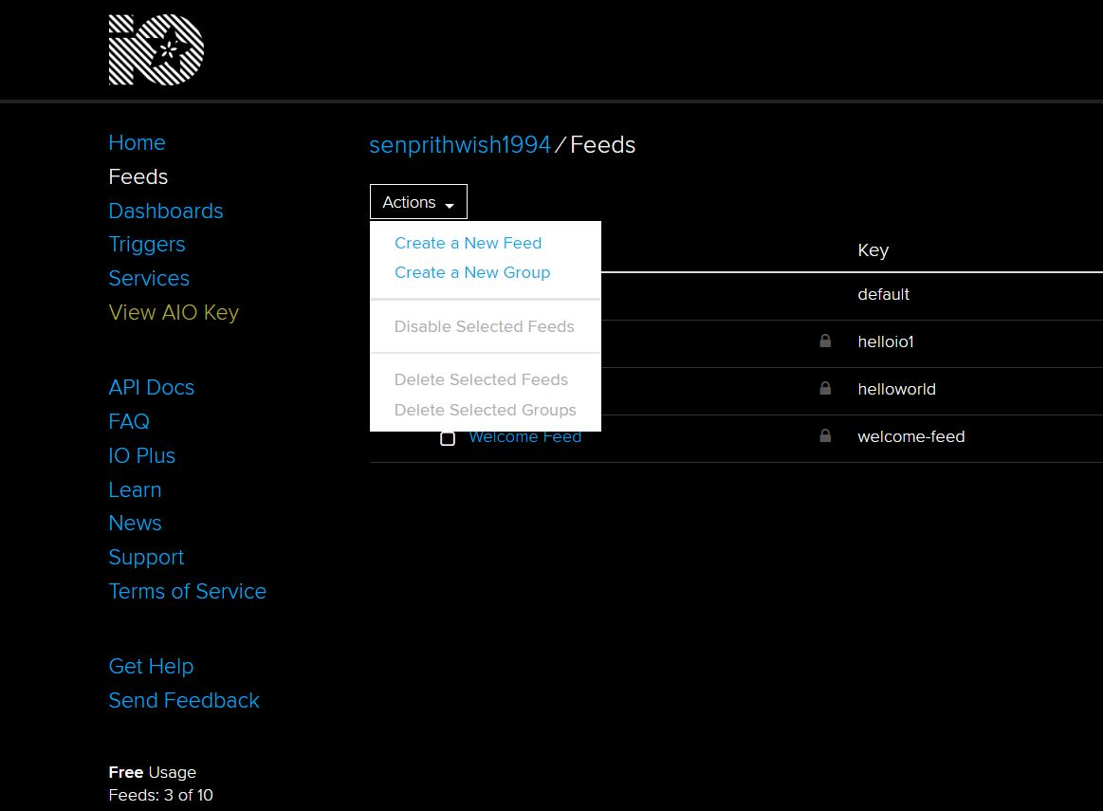**Create feed:**

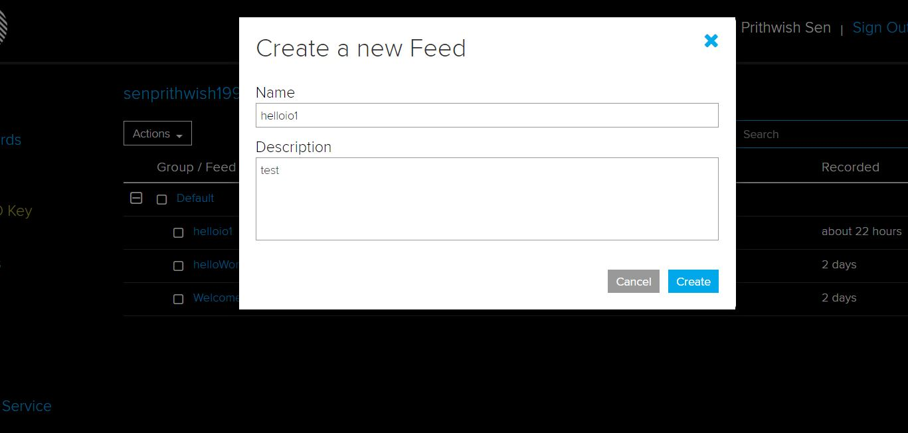

1. **Configuring IFTTT:**

**Sign up and Sign in with the same email address in IFTTT, Adafruit IO and in your Phone Google Assistant**



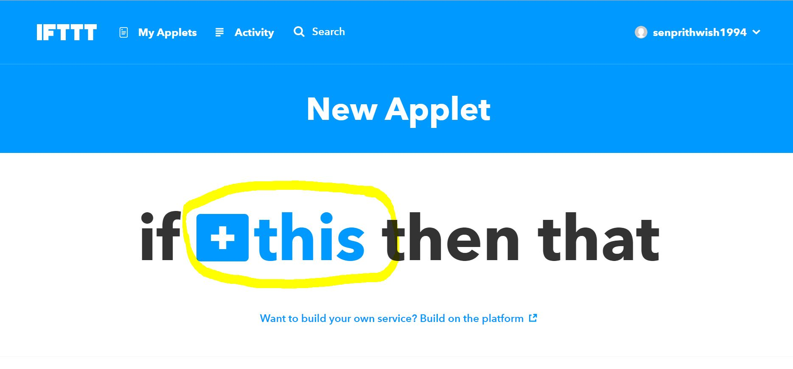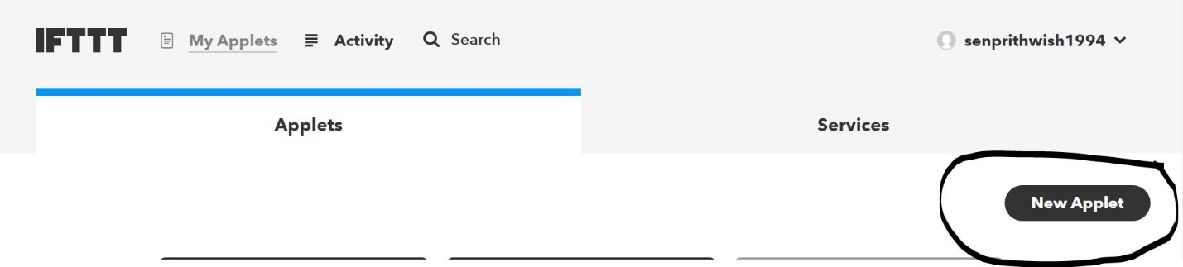

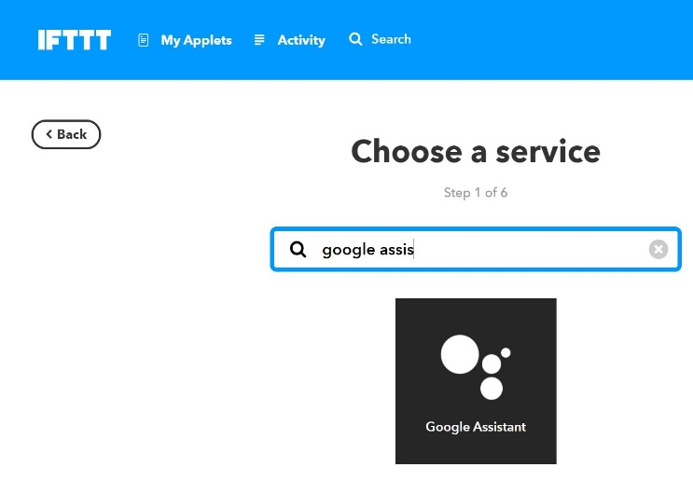

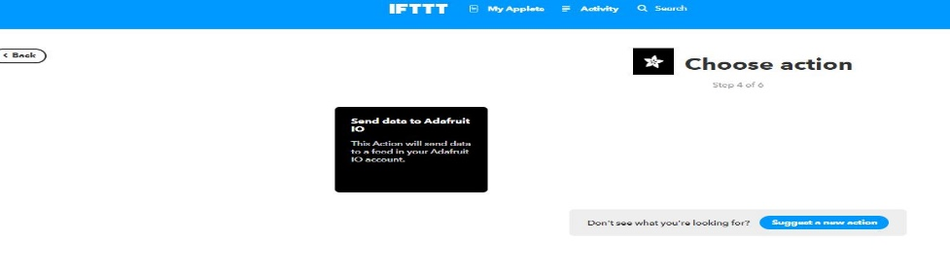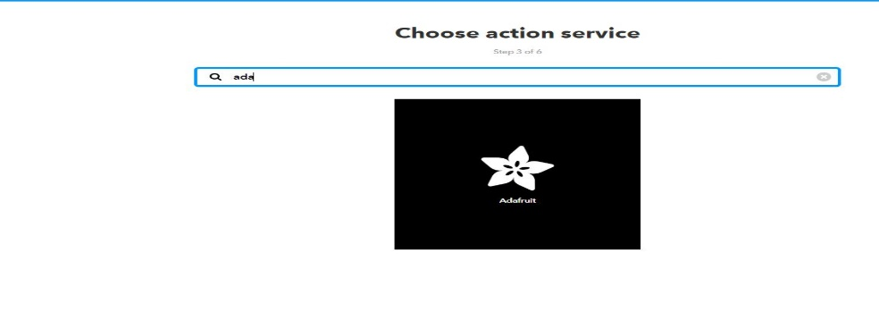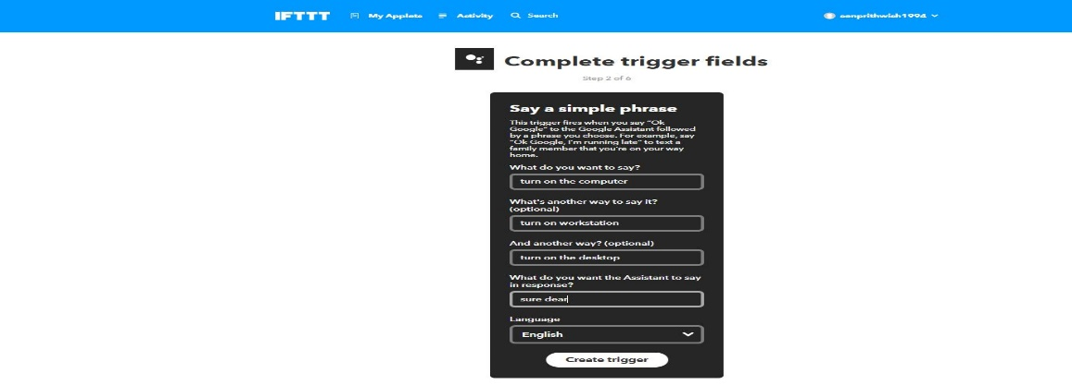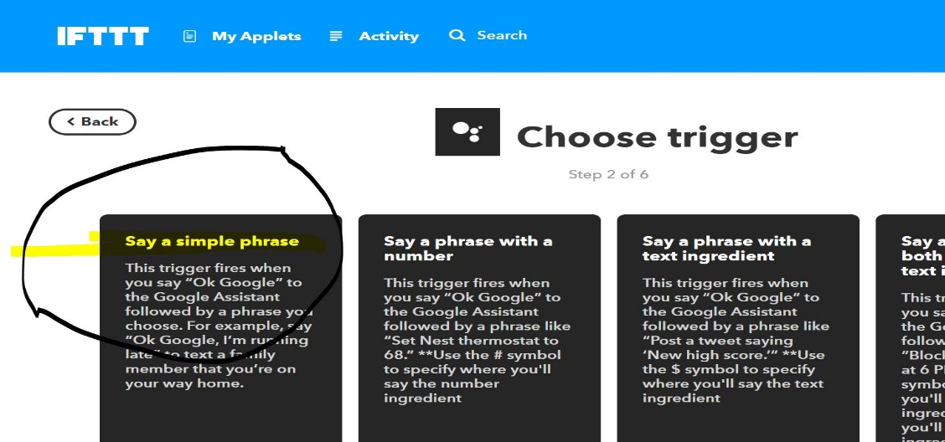

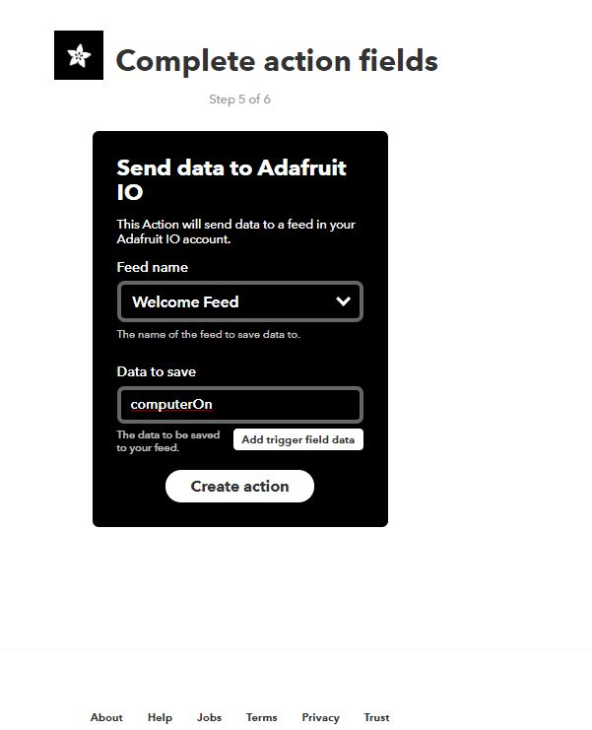

Here You must select the feed that you have created earlier in Adafruit-IO and write what data to save

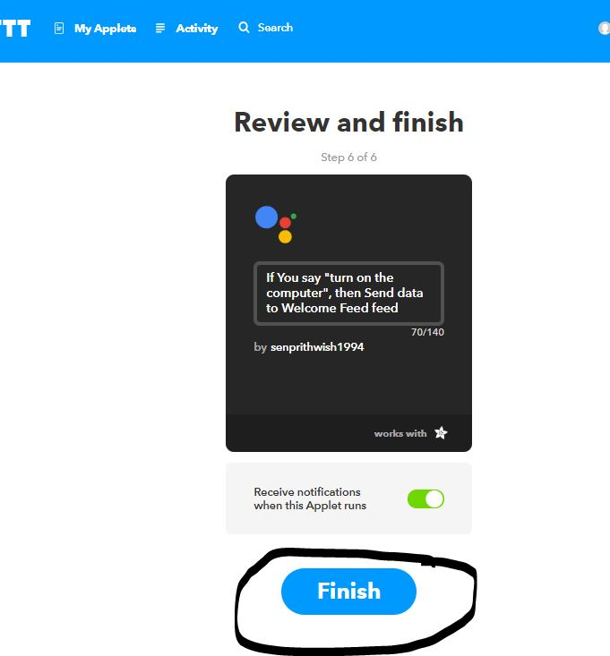Click on create action and then click on finish and then test your google assistant from your phone by saying “ok google” followed by “turn on the computer” after the google prompts back you can go and view your created feed value at adafruit io which changes with every iteration

